Claveria, Jorlyn Shane M.
Reyes, Maria Theresa N.
Segotier, Joy Melisa
Estolloso, Marc Christian
BS INFO 3C – INFOE 4 - LAB 2

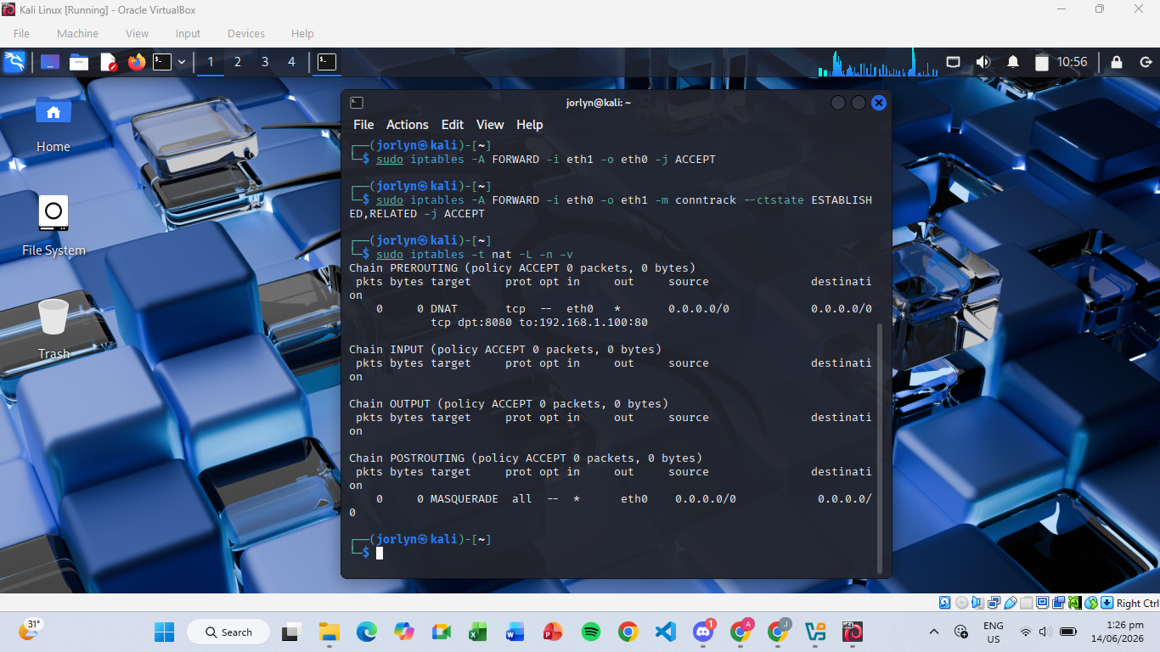
- Screenshot of iptables -t nat -L showing the MASQUERADE and DNAT targets.

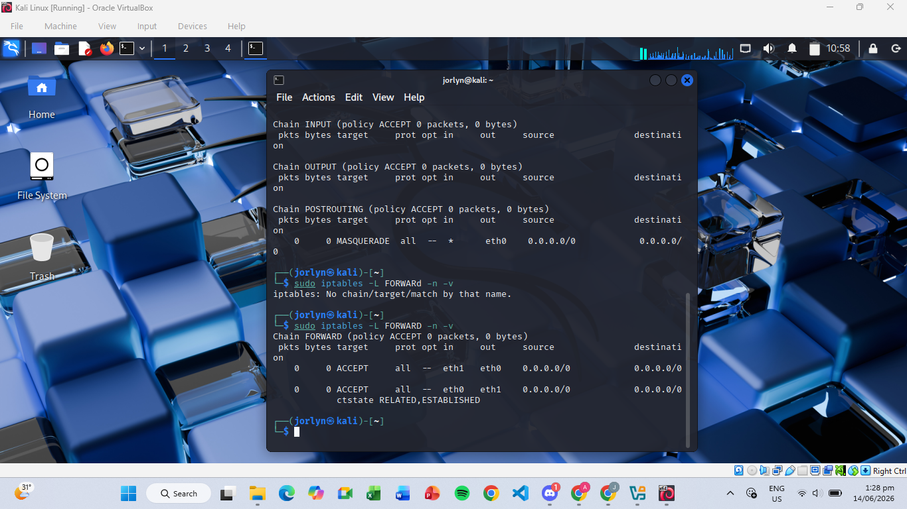
- Screenshot of iptables -L FORWARD showing the ACCEPT rules for transit traffic.

Critical Thinking & Security Analysis
1. Obfuscation: How does MASQUERADE protect the Confidentiality of the internal network's size and structure?
MASQUERADE hides the private IP addresses of internal devices by replacing them with the Gateway's public IP address. External users can only see the Gateway, making it difficult to determine the number and structure of devices inside the private network.
2. Port Remapping: We mapped Public Port 8080 to Internal Port 80. What is the security advantage of using a non-standard port on the public-facing interface?
Using port 8080 instead of the standard port 80 reduces exposure to automated scans and common attacks that usually target well-known ports. It adds a small layer of obscurity and helps separate public access from the internal server configuration.
3. The "Missing Link": If you successfully configure Part 2 (SNAT) but forget Part 1 (IP Forwarding), will the internal clients have internet? Why or why not?
Internal clients will not have Internet access. Even though NAT is configured, the Linux Gateway will not forward packets between interfaces because IP forwarding is disabled. The packets will be dropped instead of being routed to the Internet.

